“Books that teach diversity”
Grades PreK-2
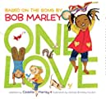 | One Love  Author: Cedelia Marley  Illustrator: Vanessa Brantley-Newton  Description: A board book that is perfect for preschoolers to learn about diversity, teamwork and love. A heartwarming story set to Bob Marley’s unforgettable lyrics.  Recommended by: Dr. Gray
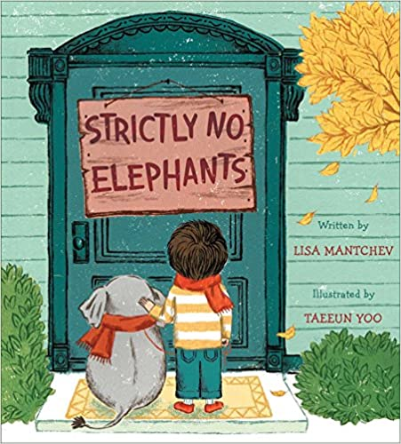 | Strictly No Elephants  Author: Lisa Mantchev  Illustrator: Taeeun Yoo  Description: This picture book has a gentle message of inclusion and helping others, this title reaches beyond a mere friendship story.  Recommended by: Dr. Gray
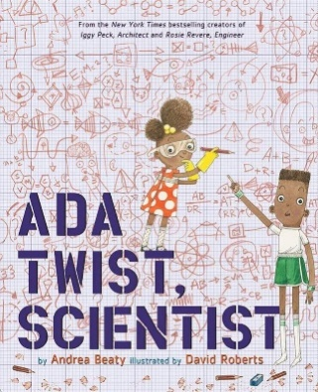 | Ada Twist, Scientist  Author: Andrea Beaty  Description: Part of a series of STEM favorites from New York Times bestseller Andrea Beaty, Ada Twist, Scientist is about Ada, a curious young girl of color with boundless passion for science. This book teaches readers age 4 to 7 about problem solving, perseverance, and science, and challenges them never to lose their sense of curiosity.  Recommended by: Rebecca Adrian
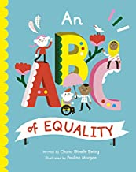 | An ABC of Equality  Author: Chana Ginelle Ewing  Illustrator: Paulina Morgan  Description: The simple illustrators accompany each letter of the alphabet with simple and child-friendly explanations of what it means to be kind, accepting, and make the world a better place than we found it.  Recommended by: Dr. Bernadowski
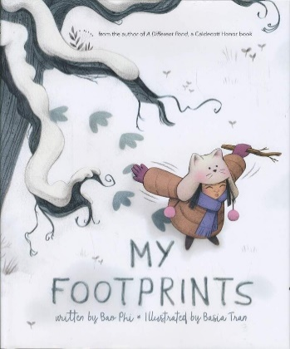 | My Footprints  Author: Bao Phi  Description: This warmhearted book, ideal for children 4 to 7 years of age, sends the message that children can draw strength on from their cultural heritage. As a Vietnamese American with two moms, Thuy is taunted by bullies for being “double different.” She dreams of flying away like a bird, sprinting off like a deer, or roaring like a bear. In the protection of her two moms, she finds courage inside herself.  Recommended by: Rebecca Adrian
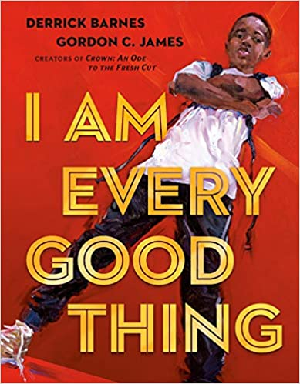 | I am Every Good Thing  Author: Derrick Barnes  Description: The confident Black narrator of this book is proud of everything that makes him who he is. He's got big plans, and no doubt he'll see them through--as he's creative, adventurous, smart, funny, and a good friend. Sometimes he falls, but he always gets back up. And other times he's afraid, because he's so often misunderstood and called what he is not.  Recommended by: Lori Zorn
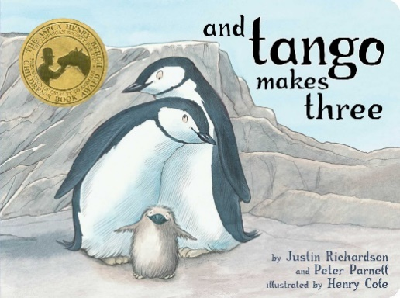 | And Tango Makes Three  Author: Justin Richardson & Peter Parnell  Description: A true story of two male chinstrap penguins who live at the Central Park Zoo and adopt and raise a baby. One of my all time favorite children's books.  Recommended by: Dr. Parker
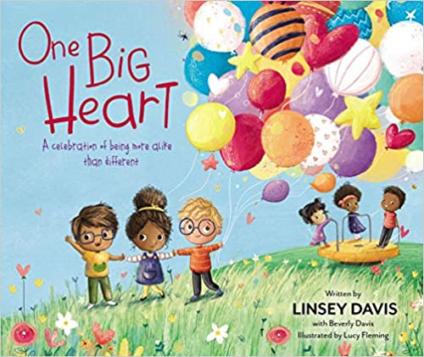 | One Big Heart: A Celebration of Being More Alike than Different  Author: Linsey Davis  Illustrator: Lucy Fleming  Description: A culture-rich picture book that showcases the beauty of diversity while also celebrating all the wonderful things we have in common.  Recommended by: Dr. Gray
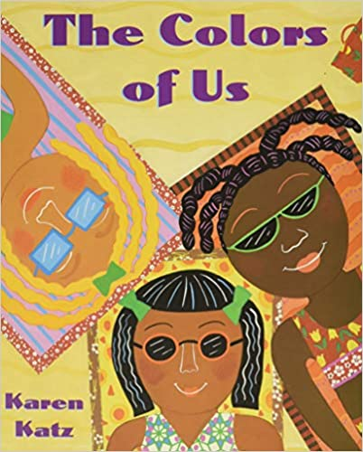 | The Color of Us  Author: Karen Katz  Illustrator: Karen Katz  Description: Lena, a seven-year-old girl, wants desperately to paint a beautiful picture of herself. As she chooses the brown paint, she realized there are many different shades of brown. This realization serves as a catalyst for conversations about the differences and similarities that we all share.  Recommended by: Dr. Bernadowski
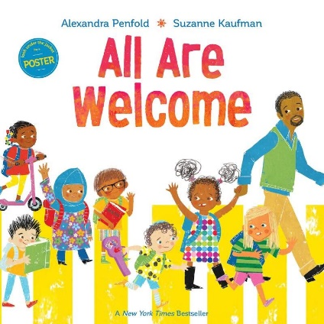 | All Are Welcome  Author: Alexandra Penfold  Description: This New York Times bestselling picture book, suitable for kids 4 to 8 years of age, invites readers into a school where kids in patkas, hijabs, and yarmulkes play alongside friends in baseball caps and T-shirts. A place where children from all cultures are welcome to learn from each other’s traditions.  Recommended by: Rebecca Adrian
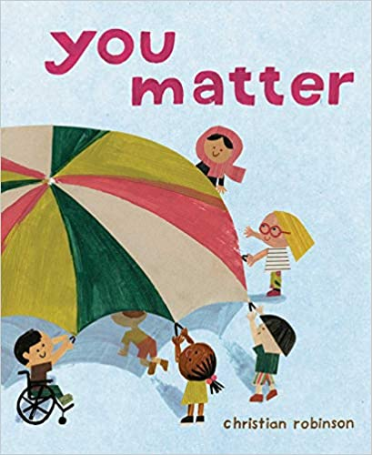 | You Matter  Author: Christian Robinson  Description: Young readers will be drawn into the luminous illustrations inviting them to engage with the world in a new way and see how everyone is connected, and that everyone matters.  Recommended by: Lori Zorn
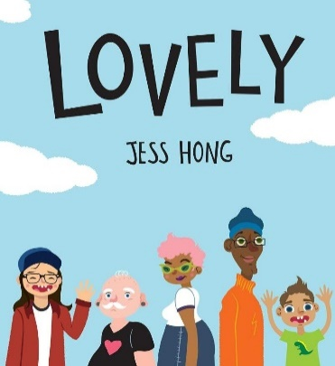 | Lovely  Author: Jess Hong  Description: This lively picture book for kids ages 4 to 8 asks the question, “What is lovely?” The answer is not what you think — and everything you hope. Lovely is big, small, curly, straight, loud, quiet, smooth and wrinkly: the differences that make us all lovely.  Recommended by: Rebecca Adrian
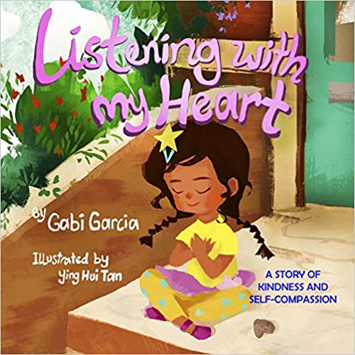 | Listening with My Heart: A story of kindness and self-compassion  Author: Gabi Garcia  Illustrator: Ying Hui Tan  Description: This book gets at the essence of how to help children be more self-compassionate – by teaching them to be a good friend to themselves. It is a must for anyone wanting to help children cope with their difficult emotions in a kind, connected and mindful manner.  Recommended by: Dr. Gray
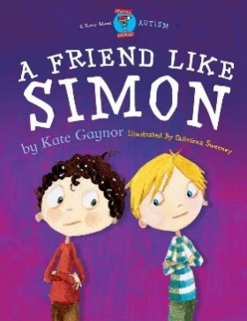 | A Friend Like Simon  Author: Kate Gaynor  Description: This brilliantly illustrated picture book introduces children ages 4 to 8 — especially those in mainstream school — to a child with autism and autism spectrum disorder (ASD). The story begins with Matthew, who meets his new classmate Simon, and sees that Simon is a little different than his other friends. During a school trip, Matthew learns to joys of having “a friend like Simon.”  Recommended by: Rebecca Adrian
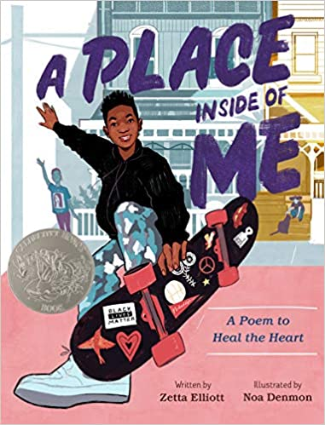 | A Place Inside of Me: A Poem to Heal the Heart  Author: Zetta Elliot  Description: The author he provides a child’s experiences following a police shooting―through grief and protests, healing and community―with washes of color as vibrant as his words.  Recommended by: Lori Zorn

Grades 3-5
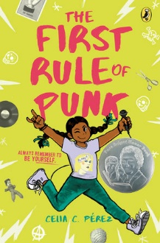 | The First Rule of Punk  Author: Celia C. Perez  Description: Readers learn from Maria Luisa (also known as Malu), a free-spirited Mexican-American girl, that the first rule of punk is to be yourself. This book offers an interesting look into many issues tweens and teens may face, including taking pride in your heritage, standing up for what you believe in, self-identify, friendship, family, and dealing with problems specific to mixed-race children in American  Recommended by: Dr. Gray
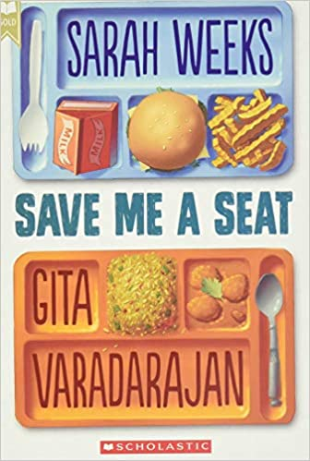 | Save Me a Seat  Authors: Sarah Weeks and Gita Varadarajan  Description: Joe's lived in the same town all his life, and was doing just fine until his best friends moved away and left him on his own. Ravi's family just moved to America from India, and he's finding it pretty hard to figure out where he fits in. Joe and Ravi don't think they have anything in common -- but soon enough they have a common enemy (the biggest bully in their class) and a common mission: to take control of their lives over the course of a single crazy week.  Recommended by: Jennifer Wachs
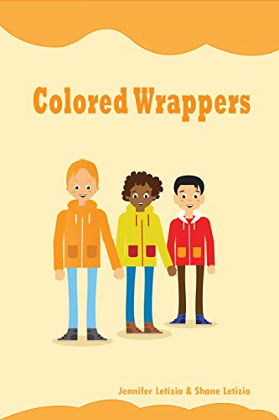 | Colored Wrappers  Authors: Jennifer Letizia  Description: The story is about Jacob, who is being bullied at school by another student name Smith for being black. The book is written from Smith’s brother's perspective. A young boy starting a new journey/school surrounded by different race children.  Recommended by: Lori Zorn
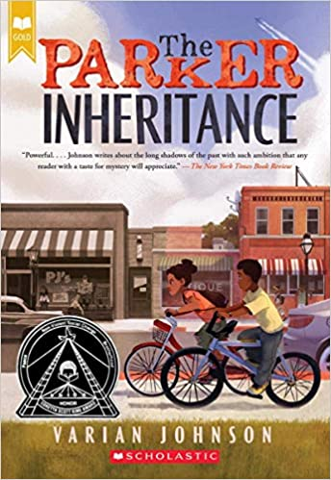 | The Parker Inheritance  Author: Varian Johnson  Description: When Candice finds a letter in an old attic in Lambert, South Carolina, she isn't sure she should read it. It's addressed to her grandmother, who left the town in shame. So with the help of Brandon, the quiet boy across the street, she begins to decipher the clues. The challenge will lead them deep into Lambert's history, full of ugly deeds, forgotten heroes, and one great love; and deeper into their own families, with their own unspoken secrets.  Recommended by: Jennifer Wachs
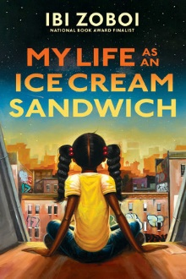 | My Life as an Ice Cream Sandwich  Author: Ibi Zoboi  Description: Twelve-year old Ebony-Grace is a space-loving girl who has to leave her grandfather in Alabama and spend the summer with her dad in Harlem. She has to learn to adapt to all the changes going on in her life while also trying to fit into her new environment.  Recommended by: Dr. Gray
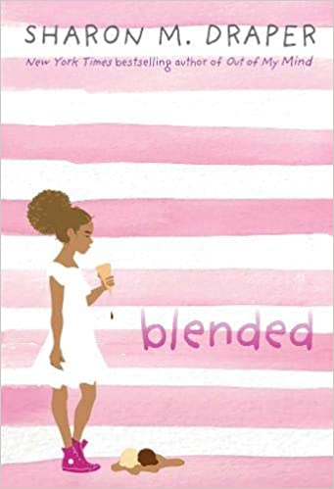 | Blended  Author: Sharon Draper  Description: Eleven-year-old Isabella’s parents are divorced, so she has to switch lives every week: One week she’s Isabella with her dad, his girlfriend Anastasia, and her son Darren living in a fancy house where they are one of the only black families in the neighborhood. The next week she’s Izzy with her mom and her boyfriend John-Mark in a small, not-so-fancy house that she loves. It seems like nothing can bring Isabella’s family together again—until the worst thing happens. Isabella and Darren are stopped by the police. A cell phone is mistaken for a gun. And shots are fired.  Recommended by: Jennifer Wachs
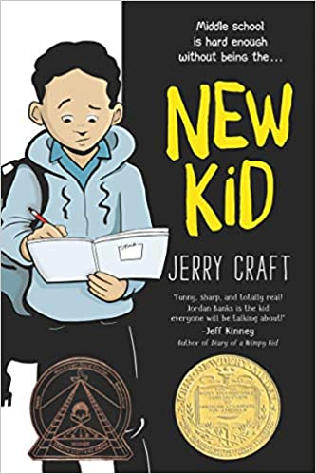 | The New Kid  Author: Jerry Craft  Description: Seventh grader Jordan Banks loves nothing more than drawing cartoons about his life. But instead of sending him to the art school of his dreams, his parents enroll him in a prestigious private school known for its academics, where Jordan is one of the few kids of color in his entire grade.  Recommended by: Jennifer Wachs
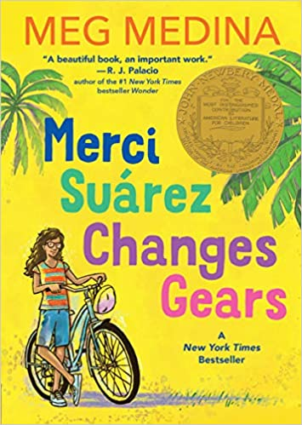 | Merci Suárez Changes Gears  Author: Meg Medina  Description: Winner of the 2019 Newbery Medal, this coming-of-age tale by New York Times best-selling author Meg Medina gets to the heart of the confusion and constant change that defines middle school — and the steadfast connection that defines family.  Recommended by: Jennifer Wachs

Grades 6-8
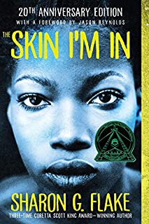 | The Skin I’m In  Author: Sharon Flake  Description: Sharon Flake’s debut novel, winner of the Coretta Scott King Award, introduces readers to Meelaka, a dark-skinned Black girl, who is teased for her homemade clothes and dark skin. She meets a new teacher that teaches her that it is okay to be different and to embrace your differences.  Recommended by: Dr. Bernadowski
Girls Resist: A Guide to Activism, Leadership, and Starting a Revolution
Author: KaeLyn Rich
Illustrator: Giulia Sagramola

Description: A guidebook for young women who want to make a difference. Teens will learn how to choose a cause, spread awareness, and work towards making change in the world. Girls are encouraged to examine their own personal privilege and biases while being guided on how to use their voices to fight for equity and justice.

Recommended by: Dr. Nena Hisle
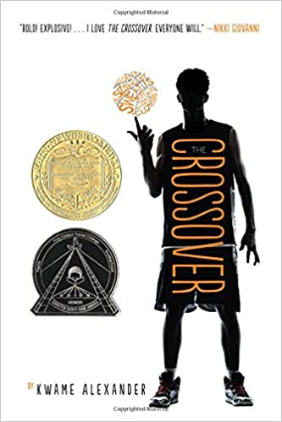 | Crossover  Author: Kwame Alexander  Description: Written in prose, Alexander introduces the Bell twin brothers, Josh and Jordan, who share a love of basketball and family until a girl comes between the once inseparable boys. This book is a must read aloud and the first in a series of must reads by Alexander (by the same name).  Recommended by: Dr. Bernadowski
The ABC’s of LGBT+ (Gender Identity Book for Teens, Teen & Young Adult LGBT Issues)
Author: Ashley Mardell

Description: An excellent resource for teens who may be questioning their identity or seeking to explore the varied identities outside of mainstream media. This is done through the use of understandable and respectful language told through the counter-stories of youths who are often silenced. It’s an even more valuable guidebook for the adults who love and work with these teens.

Recommended by: Dr. Nena Hisle
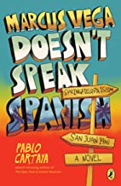 | Marcus Vega Doesn’t Speak Spanish  Author: Pablo Cartaya  Description: After Marcus Vega faces suspension for fighting in school, his mom decides to take a trip to visit relatives in Puerto Rico. Marcus remembers that his father is living on the island as well. A coming of age novel, Marcus learns a lot about being a preteen and his culture.  Recommended by: Dr. Bernadowski
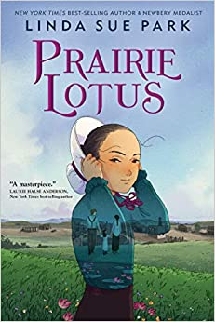 | Prairie Lotus  Author: Linda Sue Park  Description: A powerful, touching, multilayered book about a girl determined to fit in and realize her dreams: getting an education, becoming a dressmaker in her father’s shop, and making at least one friend. Narrated by Hanna, the novel has poignant moments yet sparkles with humor, introducing a captivating heroine whose wry, observant voice will resonate with readers.  Recommended by: Jennifer Wachs
I am Malala. This is my story.
Author: Malala Yousafzai & Patricia McCormick

Description: Malala, a Middle Eastern teen, shares how her life was changed after the Taliban placed restrictions on the basic rights of women in her once peaceful hometown of Pakistan. Her bravery led to her being shot while riding home from school, yet she did not low this devastating act of violence to stop her from fighting for her personal right’s.

Recommended by: Dr. Nena Hisle
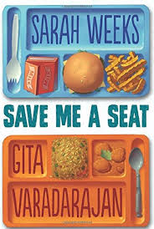 | Save Me a Seat  Author: Sarah Weeks and Gita Varadarajan  Description: Joe's lived in the same town all his life, and was doing just fine until his best friends moved away and left him on his own. Ravi's family just moved to America from India, and he's finding it pretty hard to figure out where he fits in. Joe and Ravi don't think they have anything in common -- but soon enough they have a common enemy (the biggest bully in their class) and a common mission: to take control of their lives over the course of a single crazy week.  Recommended by: Jennifer Wachs
Piecing Me Together
Author: Renee Watson

Description: Jade is a Black teenager who is struggling to avoid being cast into the stereo-typical mold of poor troubled teen from the “hood.” Although she heeds her mothers advice to leave their low-income neighborhood to attend a private school, she resists people’s natural inclination to perceive her as needing fixed.

Recommended by: Dr. Nena Hisle
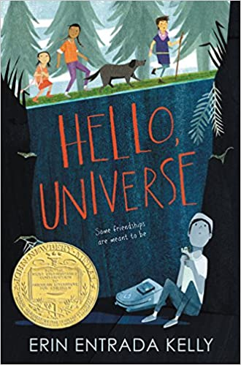 | Hello, Universe  Author: Erin Entrada Kelly  Description: In one day, four lives weave together in unexpected ways. This disaster leads Kaori, Gen, and Valencia on an epic quest to find missing Virgil. Through luck, smarts, bravery, and a little help from the universe, a rescue is performed, a bully is put in his place, and friendship blooms.  Recommended by: Jennifer Wachs

Grades 9-12
Dear Martin
Author: Nic Stone

Description: A realistic depiction of what life can be like for Black male teens as they attempt to navigate safely through the neighborhoods of any given inner-city in the United States. Justyce McAllister, a well-behaved, honor student, finds himself caught up in an encounter with the police that leaves him caught up in the crosshairs of gunfire and bound by police handcuffs.

Recommended by: Dr. Nena Hisle
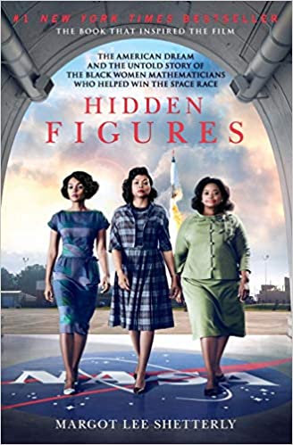 | Hidden Figures: The American Dream and the Untold Story of the Black Women Mathematicians Who Helped Win the Space Race  Author: Margot Lee Shetterly  Description: Starting in World War II and moving through to the Cold War, the Civil Rights Movement and the Space Race, Hidden Figures follows the interwoven accounts of Dorothy Vaughan, Mary Jackson, Katherine Johnson and Christine Darden, four African American women who participated in some of NASA’s greatest successes. It chronicles their careers over nearly three decades they faced challenges, forged alliances and used their intellect to change their own lives, and their country’s future  Recommended by: Jennifer Wachs

