Recommended Book List

Grades PreK-2
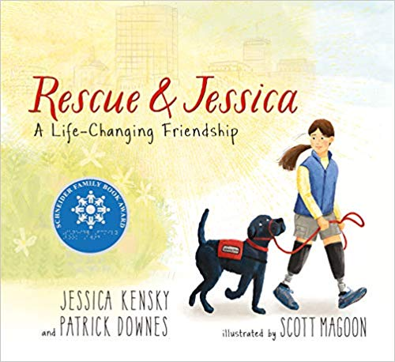 | Book Title: Rescue and Jessica: A Life-Changing Friendship  Author: Jessica Kensky and Patrick Downes  Summary: Loosely based on the experiences of the author, this book describes how the lives of Jessica and her service dog, Rescue, change and grow. It is appropriate for children in K to grade 4 and was the 2019 Schneider Family Book Award for Young Children’s Book.  "I like the positive ability message that this book sends. Young children will love it for the friendship between Jessica and Rescue and older children and adults will appreciate the symbolism in the story and illustrations.” –Dr. Vicki Donne
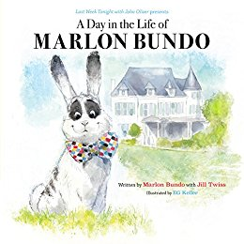 | Book Title: A Day in the Life of Marlon Bundo  Author: John Oliver  Summary: When Marlon Bundo falls in love with a boy bunny, he and his friends face opposition, but their love has the ability to change the views of others as they persevere.  “This book encourages tolerance and diversity in young children and also shows how changes within society should be embraced and accepted instead of shamed.” – Ashley Messner
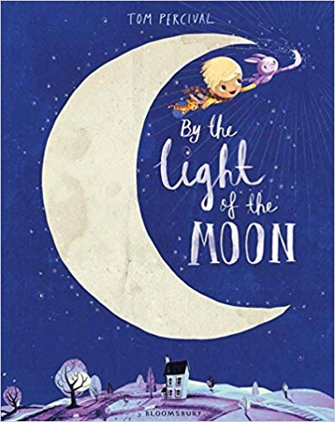 | Book Title: By the Light of the Moon  Author: Tom Percival  Summary: Moving to a new home is difficult for Ivan. He doesn’t like the home and refuses to try and give it a chance. Magically, the moon turns into a friendly monster that takes him on adventures and shows him that change can be good if we just give it a chance.  "I recommend this book because it demonstrates the power of imagination." –Dr. Carianne Bernadowski
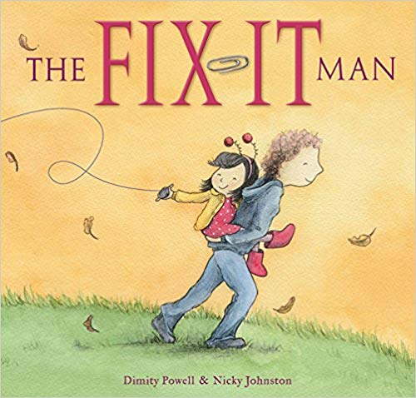 | Book Title: The Fix-It Man  Author: Dimity Powell and Nicky Johnston  Summary: After the death of her mother, a young girl realizes that her father, the man who could fix anything, does not know how to fix their broken hearts. Through trials and tribulations, the young girl and her father find a way to fix their hearts and relationships and find the resilience to move forward with their new lives.  "I recommend this book because it shows young children that adults need help and support through tough times, also." –Dr. Carianne Bernadowski

Grades 3-5
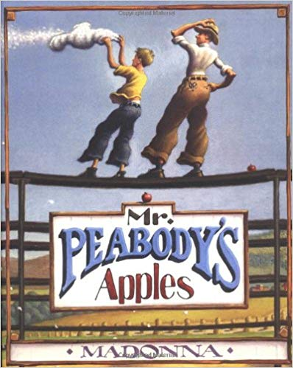 | Book Title: Mr. Peabody’s Apples  Author: Madonna  Summary: The children of Happville cannot understand why Mr. Peabody, their baseball coach and history teacher, would walk over to Mr. Funkadeli's Market, pick the shiniest apple out of the bunch, put it in his pocket, and walk away without paying for it each day. Although the children do not know the entire story and cannot make sense of it all, one of the young boys decides to start a rumor that Mr. Peabody steals apples from Mr. Funkadeli, and the rumor spreads like wildfire throughout the town of Happville.  “This short story demonstrates that in order for a child to grow and become more mature, he or she must be aware of all of the damage that a simple rumor can cause.” –Natalie Groscost

Grades 6-8
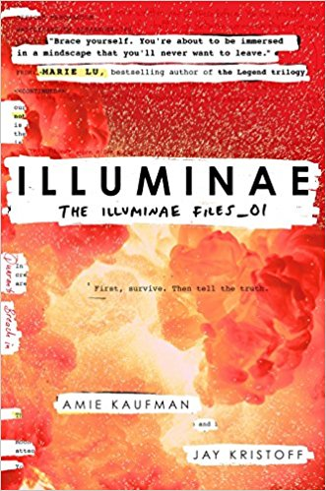 | Book Title: Illuminae  Author: Amie Kaufman and Jay Kristoff  Summary: Illuminae by Amie Kaufman and Jay Kristoff is a science fiction thriller told through the various narratives of those aboard several science space vessels fleeing a corporate-sponsored genocide. Kady Grant was only in high school when a foreign invasion on her planet sent her and her community running from murderous thugs. In this first book of a trilogy-length series, readers can watch Kady grow from student to computer engineer as she tries to save those she loves most.  “I recommend Illuminae specifically in its audiobook format. Voiced by a full cast, this story reads more like a radio drama and really pulls readers into the story. You can really see Kady's character grow in this action-packed story set in a futuristic space scene. Despite being a science fiction book, the story itself has a lot of relevant topics. These include corporate greed and the ethics of artificial intelligence.” –Savanah Buhite (RMU Alum: 2017)
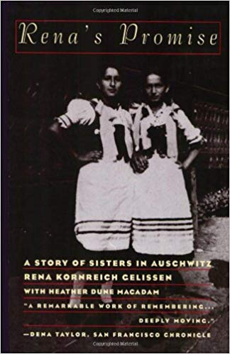 | Book Title: Rena’s Promise: A Story of Sisters in Auschwitz  Author: Rena Kornreich Gelissen  Summary: Arriving at Auschwitz on the first transport, Rena never thought she'd be strong enough to survive the death camp. That is, until she realizes her sister is right there with her. Rena realizes she can no longer waste away in the horror around her and makes a promise to herself that she will make it out of Auschwitz alive.  “This true story sheds more light on the horrors of Nazi Germany while simultaneously preserving the incredible story and bond between two sisters.” –Kayla Ford (RMU Alum: 2017)

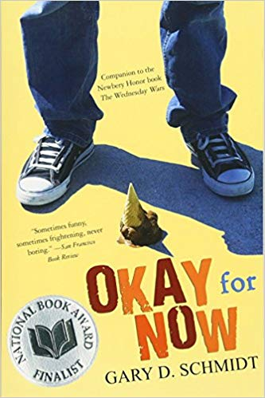 | Book Title: Okay for Now  Author: Gary Schmidt  Summary: Doug Swieteck, the engaging narrator of this award-winning novel, confronts the challenges of adolescence with courage: his struggles to make friends in a new town, his attempts to hide his learning disability, and his brother's return from the Vietnam War are just the tip of the iceberg.  “Gary Schmidt is a master at writing novels that bring comedy and heart to serious issues -- and he writes compelling characters that readers come to love. As one Amazon reviewer says, "I'm reminded that great books don't always have to be over 500 pages long with tiny font sizes and filled with heavy, ponderous thought-matter. Instead they can be unassuming, with a slightly tacky cover and filled with the every-day life of a boy, Doug, who deals with an abusive father (although you wouldn't hear him admit it), a bully of a brother, a mother with a beautiful smile and a whole cast of characters making up the stupid town life of a stupid small town in New York." –Dr. Connie Ruzich
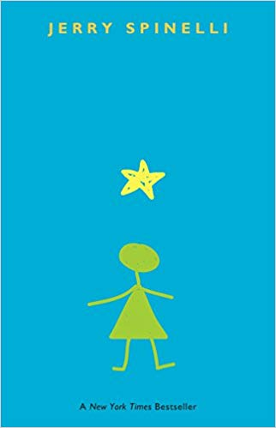 | Book Title: Stargirl  Author: Jerry Spinelli  Summary: Stargirl has been homeschooled up until the tenth grade, and this is when she starts school at Mica High. She is "different" from her peers she goes to school with, yet the students are fascinated by her  “This is a novel that proves being part of the "in-crowd" in high school is one thing, but one being able to fully embrace who she is, flaws and all, is a true demonstration of growth, maturity, and self-love.” –Natalie Groscost

Grades 9-12
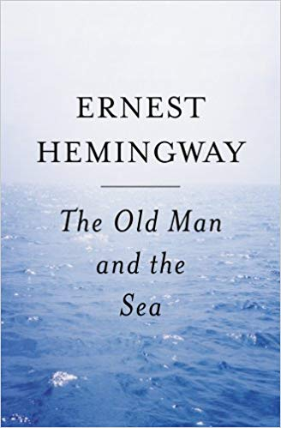 | Book Title: The Old Man and the Sea  Author: Ernest Hemingway  Summary: This short Pulitzer Prize novel tells the story of an old fisherman and a boy who set out in a small skiff to fish. The story builds as the old man catches a large (perhaps largest on record) marlin after a struggle that lasted days. On his return to land, the marlin is devoured by sharks. Thus, the record catch is only now in the minds of the old man and the boy.  “The theme focuses on the struggle and what impact in had on the old fisherman. The story is also rich in symbolism relative to the role of the old man, the marlin, etc. It certainly is worth a read since the old man and the boy changed and grew from the experience with the marlin.” –Dr. George Semich
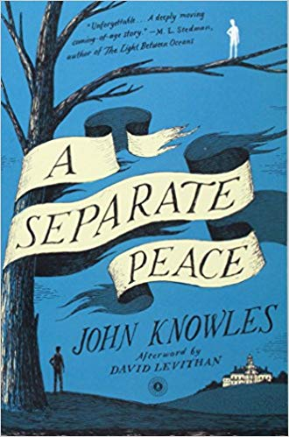 | Book Title: A Separate Peace  Author: John Knowles  Summary: A coming of age novel of three teenage boys growing up at the Devon School, a private school in New Hampshire. With the backdrop of the war, these three boys try to live their lives amidst the pressures of becoming a part of the war effort. The friendship between the three reaches a crisis when Leper enlists and Gene through a conscious or unconscious act shakes a tree branch that results in an injury that would eventually end Phineas's life. Gene relives these series of events as he returns to Devon School fifteen years later as he tries to find his separate peace after the war.  “This coming of age novel is very well-written and highlights all of the major elements of a short story.” –Dr. George Semich

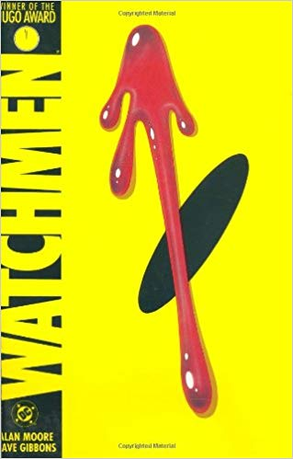 | Book Title: Watchmen  Author: Alan Moore  Summary: A murder mystery-turned-nationwide conspiracy, Watchmen examines the lives of the eponymous superhero team as they seem to decay alongside the ever-darkening America around them. Rorschach, Nite Owl, the Silk Spectre, Dr. Manhattan and Ozymandias reunite to investigate who’s behind a teammate’s murder, but find that the truth may be even more grim than the world they seek to protect (Summary from Amazon).  “An alternate history account of the United States during and after Vietnam following a new generation of costumed adventurers. Not only does this chronicle the personal changes and growth of individual characters, such as Nite Owl and Dr. Manhattan (the latter being an omniscient being who initially lacks all empathy), but the change and growth of the United States as a whole during the Cold War. Paranoia runs rampant with citizens becoming less and less trusting in once highly respected heroes, with the general public continuously asking ‘who watches the Watchmen?’” –Dom Weisser (RMU Alum: 2017)
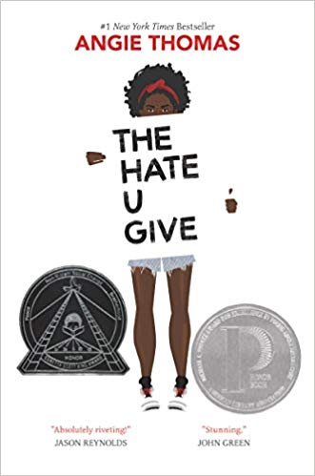 | Book Title: The Hate U Give  Author: Angie Thomas  Summary: Starr Carter's attempt to navigate her home world, a poor, mostly black neighborhood ravaged by drug crime, and her school world, a mostly wealthy white prep school, is shattered by her witnessing of a police shooting of a close friend.  “This novel is a modern-day To Kill a Mockingbird, with a protagonist who is as engaging as Scout Finch, yet is an actor, not an observer.” –Mary Catherine Kiliany
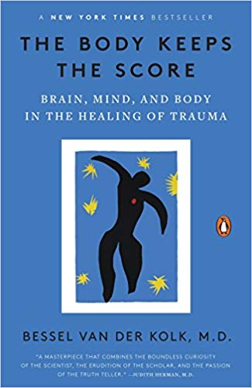 | Book Title: The Body Keeps the Score: Brain, Mind, and Body in the Healing of Trauma  Author: Bessel Van Der Kolk  Summary: A nonfiction self-help book which describes how the brain and body both survive and adapt to trauma and ways that an individual can heal and adjust to the changes.  “This is a great book for anyone who is interested in how the brain operates under extreme stress and trauma as well as how it heals from that as well as anyone who is seeking help for themselves in order to change and grow as a person.” –Ashley Messner

