Maintaining Student Attributes

Student Attributes are maintained using the Additional Student Information SGASADD page. Student Attributes are effective term driven and are valid for all terms within the ‘From Term’ and ‘To Term’ range listed for each record. Student Attributes can be used to drive rules for Registration, Fee Assessment, Degree Audit and Scheduling.
and in batch using the General Student Mass Entry SGAMSTU page for New Freshmen and new Transfer students.

This document contains the following sections:

Add a Student Attribute
End a Student Attribute

Add a Student Attribute

The Additional Student Information SGASADD page is used to add a Student Attribute to an individual student. This page is an effective term driven page which tracks changes in this record over terms.

- Enter SGASADD in the Welcome box and press the Enter Key.

- Enter the student ID in ID field (or query using the Search).

- Enter the Term the Student Attribute is effective for in Term field (or query using the Search) and click GO.

- Click Next Section

- Verify that the ‘From Term’ is equal to the Term entered in the key Block.

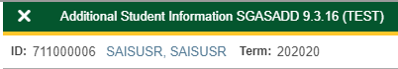

  - If the ‘From Term’ is not equal to the Key Block Term:

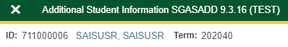

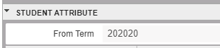

  - Click the Maintenance Icon to create a Key Block Term record with a copy of the existing Student Attributes.

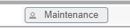

  - Choose Copy Student Attribute from the Options List.

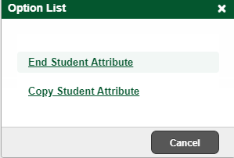

  - A Registration Fee Assessment warning will display, click OK and continue.

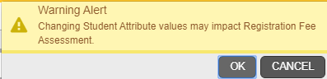

- Enter the Student Attribute code in the Attribute Code field.

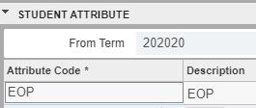

- Save

- A Registration Fee Assessment warning will display, click OK and continue.

- If the term in the ‘To Term’ field is 999999, continue to step 10). If the term in the ‘To Term’ field is not 999999, a future record exists and will also need to be updated.

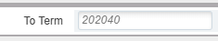
  - Click Start Over

  - Enter the term listed in the ‘To Term’ field in the Keyblock Term field and click GO.

  - Click Next Section

  - Click Insert

  - Enter the new Student Attribute code in the Attribute field.

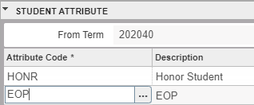

  - Save

  - A Registration Fee Assessment warning will display, click OK and continue.

  - Repeat this step until 999999 is listed in the ‘To Term’ field and then Exit.

- All terms within the ‘From Term’ and ‘To Term’ fields of the SGASADD records that been updated that also have registration will need to be recalculated.

  - Enter SFAREGQ in the Welcome Box and hit Enter to review registered terms. All terms that have registration and are with the ‘From Term’ and ‘To Term’ fields of the SGASADD record will need to be recalculated.

  - Enter a date range in the Registration ‘From Date’ field and Registration ‘To Date’ fields to query multiple terms.

  - Enter the student ID in ID field (or query using the Search) and click GO.

  - Terms of Enrollment will display.

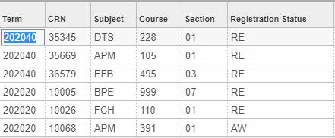

  - If none of the Terms within effective term range of the SGASADD records that have been updated are listed, registration fees will not need to be recalculated. This process is complete. Exit.

  - If any of the Terms within the effective term range of the SGASADD records that have been updated are listed, the fees for those terms will need to be recalculated in the Registration SFAREGS page. Exit and Continue to the next step.

  - Enter SFAREGS in the Welcome Box and hit Enter.

  - The first time the Registration SFAREGS page is accessed in a Banner session, the Student System Distribution Initialization SOADEST page will display. Click the X to close the page.

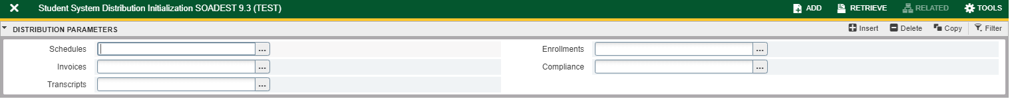

  - Enter the Term registered (from step 10) e.) in the Term field.

  - Enter the student ID in ID field (or query using the Search) and click GO.

      - If Registration Hold enforcement is ever changed to Fatal in SOATERM and the student has a Registration Hold and you are authorized to register the student without the student clearing the Hold, perform the following steps:
- Clear the Error by clicking on the number 1 in the yellow square.

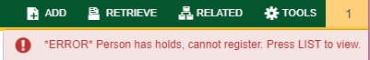

    - Enter the Hold Override code from SOATERM in the Holds field and click GO.

  - Click Save twice and Exit.

  - Repeat this step for each registered term that is within the ‘From Term’ and ‘To Term’ fields of the SGASADD records that been updated.

End a Student Attribute

The Additional Student Information SGASADD page is used to end a Student Attribute for an individual student. This page is an effective term driven page which tracks changes in this record over terms.

- Enter SGASADD in the Welcome box and press the Enter Key.

- Enter the student ID in ID field (or query using the Search).

- Enter the Term the Student Attribute is effective for in Term field (or query using the Search) and click GO.

- Click Next Section

- Verify that the ‘From Term’ is equal to the Term entered in the key Block.

  - If the ‘From Term’ is not equal to the Key Block Term:

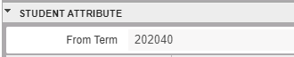

  - Click the Maintenance Icon to create a Key Block Term record with a copy of the existing Student Attributes.

  - Choose Copy Student Attribute from the Options List.

  - A Registration Fee Assessment warning will display, click OK and continue.

- Select the Student Attribute code in the Attribute Code field to be ended and click Delete.

- A Registration Fee Assessment warning will display, click OK and continue.

- Save

- If the term in the ‘To Term’ field is 999999, continue to step 10). If the term in the ‘To Term’ field is not 999999, a future record exists and will also need to be updated.

  - Click Start Over

  - Enter the term listed in the ‘To Term’ field in the Keyblock Term field and click GO.

  - Click Next Section

  - Click Insert

  - Enter the new Student Attribute code in the Attribute field.

  - Save

  - A Registration Fee Assessment warning will display, click OK and continue.

  - Repeat this step until 999999 is listed in the ‘To Term’ field and then Exit.

- All terms within the ‘From Term’ and ‘To Term’ fields of the SGASADD records that been updated that also have registration will need to be recalculated.

  - Enter SFAREGQ in the Welcome Box and hit Enter to review registered terms. All terms that have registration and are with the ‘From Term’ and ‘To Term’ fields of the SGASADD record will need to be recalculated.

  - Enter a date range in the Registration ‘From Date’ field and Registration ‘To Date’ fields to query multiple terms.

  - Enter the student ID in ID field (or query using the Search) and click GO.

  - Terms of Enrollment will display.

  - If none of the Terms within effective term range of the SGASADD records that have been updated are listed, registration fees will not need to be recalculated. This process is complete. Exit.

  - If any of the Terms within the effective term range of the SGASADD records that have been updated are listed, the fees for those terms will need to be recalculated in the Registration SFAREGS page. Exit and Continue to the next step.

  - Enter SFAREGS in the Welcome Box and hit Enter.

  - The first time the Registration SFAREGS page is accessed in a Banner session, the Student System Distribution Initialization SOADEST page will display. Click the X to close the page.

  - Enter the Term registered (from step 10) e.) in the Term field.

  - Enter the student ID in ID field (or query using the Search) and click GO.

      - If Registration Hold enforcement is ever changed to Fatal in SOATERM and the student has a Registration Hold and you are authorized to register the student without the student clearing the Hold, perform the following steps:
- Clear the Error by clicking on the number 1 in the yellow square.

    - Enter the Hold Override code from SOATERM in the Holds field and click GO.

  - Click Save twice and Exit.

  - Repeat this step for each registered term that is within the ‘From Term’ and ‘To Term’ fields of the SGASADD records that been updated.

