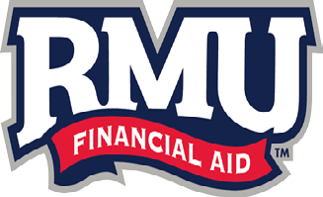 | Federal Home Loan Bank of Pittsburgh  EMPLOYEE VERIFICATION FORM  15% Tuition Discount on Fully Online Undergraduate Degree Programs and Fully Online and On Ground Master’s Degree Programs. Doctorate and Nursing Programs are  Excluded

Please fill out the form completely and return to the Financial Aid Office at Robert Morris University –
6001 University Blvd, Moon Township, PA 15108 or fax to: 412-397-6499 Attn: Stephanie Hendershot or email: hendershot@rmu.edu

SECTION 1

Employee Name (please print)

RMU ID: Email

SECTION 2

The applicant will be enrolled in a fully online undergraduate degree program and/or a fully online and on ground Master’s Degree Program. Doctorate and Nursing Programs are excluded.

Term Enrolled:

*Form must be completed for each term enrolled or discount will not be applied

SECTION 3

Employee Signature_ Date

Federal Home Loan Bank of Pittsburgh:
I certify the above employee is currently employed by Federal Home Loan Bank of Pittsburgh and is eligible for the tuition discount.
Name: Title: Signature Date

