UpToDate® Anywhere Access Tip Sheet

Getting Registered

- Access UpToDate by going to https://reddog.rmu.edu/login?url=https://www.uptodate.com/online

- Click the Log In/Register button in the upper right corner of the screen.

- To register, complete all fields on the right side of the registration page and then click Submit Registration.

- If you already have an UpToDate User Name and Password, log in on the left side of the registration page.
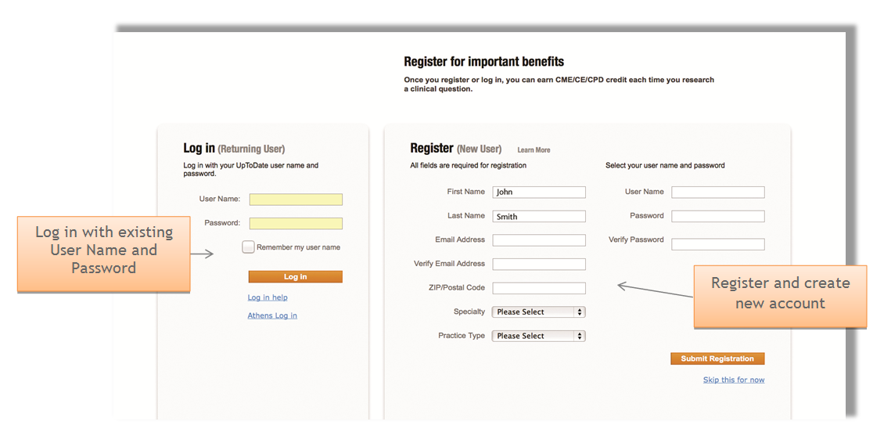
Upon completion of the registration process, you will receive a confirmation email from UpToDate with instructions on downloading the Mobile App.

You are now registered and able to download the Mobile App

Mobile Access
Once registered, you can install the Mobile App on up to two devices by following the instructions below:

- On your smartphone or tablet, click on your App Store icon
Examples:
https://itunes.apple.com/us/app/uptodate/id334265345?mt=8
or:
https://play.google.com/store/apps/details?id=com.uptodate.android&hl=en
- Search for “UpToDate” in your app store, click and install the free app.
- Open the UpToDate Mobile App upon completion of download.
- Log in with your UpToDate User Name and Password. You only need to do this once – the app remembers your User Name and Password. This is the password you just created during the registration login process. This is not your Sentry login/ password.
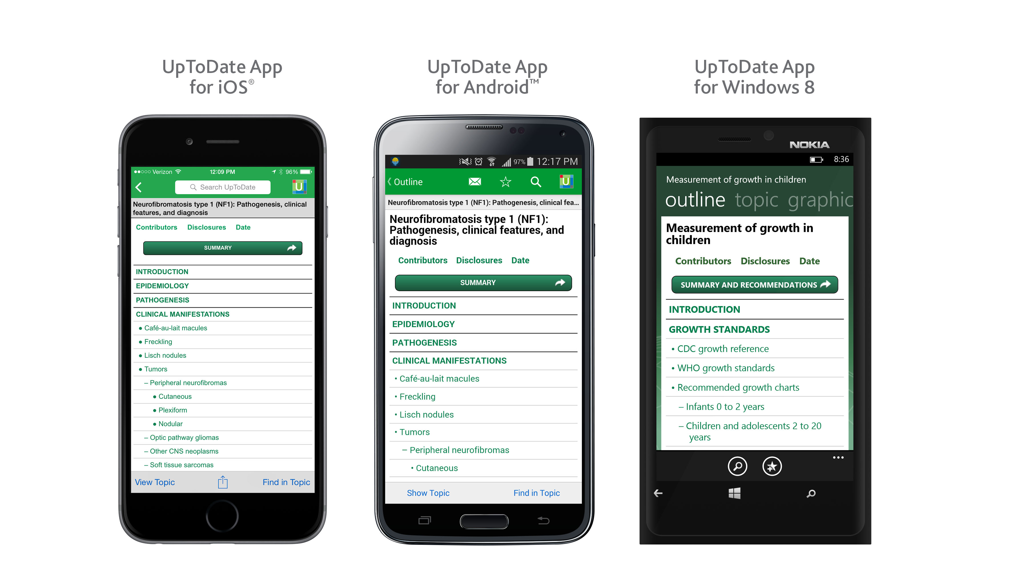
Access UpToDate Anywhere
- In addition to the Mobile App, you can access UpToDate from any computer with internet access.

Maintaining Access

- In order to maintain uninterrupted access to UpToDate Anywhere, you must re-verify your affiliation with your organization once every 90 days, (this can be done by navigating to the RMU library homepage, (https://library.rmu.edu), selecting Research by Subject -> Nursing -> UpToDate -> then, entering your Sentry login & password.

Please Note: In-application & email messaging will inform you of the need to verify affiliation if you have not done so by day 90. You will receive a second alert at day 80. If you fail to re-verify by day 90, you will lose mobile and remote access. To regain access, please complete the re-verification process outlined above.

